CHAPTER 4: Systems — living connections
Worksheet 4.3

Blood and blood highways
Student: Class:

Blood flow through the heart
1. The diagram below shows a cross-section of the heart. Use it to answer the following questions.
(a) The chambers of the heart are code labelled. State their names.
RA: RV:
LA: LV:
(b) Deoxygenated blood enters the heart at S1 and S2. Identify which parts of the body these vessels come from.
S1: S2:
(c) Identify the artery labelled X .
(d) The oxygenated blood leaves the heart at F. Complete the following flowchart using symbols and names to show the route of the blood in and out of the heart.
(S1/S2)→( )→( )→(pulmonary artery)→lung→( )→(LA)→( )→(F)

Blood cells
2. Blood is a mixture of red cells, white cells and platelets in a yellow liquid called plasma. The average adult contains 5000 mL of blood. This volume of blood contains 35 trillion
(35 000 000 000 000) red blood cells. Each drop of blood contains 250 million (250 000 000)
red blood cells, 400 000 white blood cells and 15 million (15 000 000) platelets.
Red blood cells take on average 20 seconds to travel once around the body and return to the heart. The lifetime of a red blood cell is about 120 days.
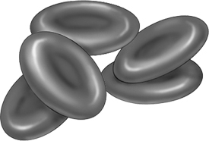 | (a) Calculate the volume of one drop of blood.  (b) Calculate the total number of white blood cells and the total number of platelets in an average adult.
(c) Identify the blood cells illustrated.
(d) Calculate the number of circuits of the body that a red blood cell makes during its lifetime.

